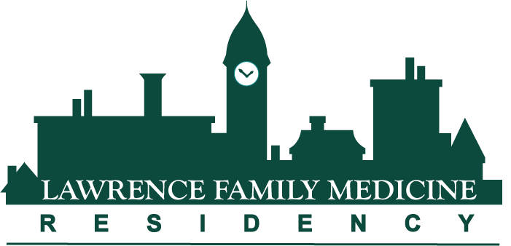

**Lawrence Family Medicine Residency HSM Curriculum**

**Health Systems Management Curriculum Overview**

Residency programs must prepare residents to practice in a transforming healthcare system, providing curricular experiences that traditionally have not been part of residency education but need to be. Our residency is committed to preparing residents not just for the next 3-4 years but for the more distant future as well. We are committed to preparing residents to be leaders and patient advocates, not only able to adjust to changing practice environments and a changing healthcare system but to lead it on various levels to a better place.

We believe that family medicine is the specialty most aligned with achieving the “Quadruple Aim” – improving the health of populations, improving the patient experience of healthcare, reducing the cost of health care, and maintaining joy in our practice. Higher quality and lower cost can only be achieved by understanding not only care for the individual patient but also understanding (and improving) the current healthcare delivery system. Understanding that context in which family physicians practice and patients receive care, and in fact acquiring leadership and management skills in this context, is the best chance to achieve a truly value-based, patient-centered healthcare system.

The Health Systems Management curriculum has 5 major components:

1) Residents are based in an NCQA Level 3 Patient-Centered Medical Home (PCMH) practice in a team based setting. Teams are composed of family medicine faculty attendings (residents are paired with their advisor), residents, NPs, RNs, MAs, Patient Service Representatives (front desk personnel), pharmacists, outreach coordinators, and mammography personnel. Teams meet regularly to work toward improving population based health care and patient experience of care in the clinic.

2) Thursday afternoon class conferences (with associated readings) on HSM topics (see category list below).

3) Year of training-based scheduled experiential Health Systems Management individual activities (with associated readings), 10 per year for 4 years.

4) 6 week Clinical Chief block rotation for all 4th year residents.

5) Residents with special interest in Health Systems Management, often intending to serve HSM-related leadership roles in the future, may participate in the Health Systems Leadership Area of Concentration.

**Health Systems Management (HSM) Components**

1. **PCMH**

Our residency’s PCMH is organized into 4 teams, named *Amarillo* (Yellow), *Azul* (Blue), *Rojo* (Red) and *Verde* (Green). Teams are located in one of 4 “pods” at our Haverhill Street residency practice location. There are two residents per class on each team, as well as three to four attendings. Clinical support personnel (NPs, RNs, MAs, PSRs, pharmacy, mammography) are assigned to teams as well so that residents get to know team members very well. Teams are further subdivided into teamlets, so as to provide a smaller working group. Patient registries and the team’s clinical performance measures for each team are regularly reviewed and PDSA cycles implemented to improve operational efficiency and clinical quality.

The PCMH model promotes partnerships between patients and their family physicians. The PCMH creates a medical team who will provide for all of a patient’s health care needs and will coordinate treatments across the health care system. Patient Centered Medical Homes demonstrate the benchmarks of patient-centered care by implementing open scheduling, extended clinical hours, and an effective use of current and expanded health information systems. To receive recognition, GLFHC demonstrated the ability to meet the program’s key elements. They include appropriate use of charting tools to track patients and organize clinical information, responsive care management techniques, as well as advanced use of information technology for prescriptions and care management. The standards are aligned with the joint principles of the Patient-Centered Medical Home established with the American College of Physicians, the American Academy of Family Physicians, the American Academy of Pediatrics, and the American Osteopathic Association.

1. **Thursday afternoon HSM class conferences**

Interactive residency class-specific HSM conferences are held on Thursday afternoons interspersed with other medical topics. First year conferences provide foundational HSM knowledge and skills, advancing to higher degrees of complexity through the fourth year. Residents also attend the MassAFP’s Family Medicine Day at the State House in Boston to learn and practice advocacy skills important to advocate for system change for patients’ benefit.

1. **Experiential Health Systems Management individual scheduled activities**

Expertise in Quality Improvement is an increasingly important skill set for those leading practice-based learning and improvement efforts. Besides the professionalism and medical ethics aspect of providing the highest quality care in the safest way possible for patients, the US healthcare system is currently undergoing transformational payment reform that will better value those physicians practicing in such a way so as to achieve the Quadruple Aim. Particular emphasis is therefore placed on training residents to be able to be leaders in QI in their future practices. A goal of this curriculum is that all residents achieve Institute for Healthcare Improvement (IHI)Open School basic certification. Residents also attend weekly “Journal Club” sessions on HSM topics with the residency’s Site Medical Director as part of these longitudinally scheduled activities.

Specific curricular areas include performance measurement and improvement, quality and safety, community health center operations and governance, payment systems and finance, regulatory and medical-legal aspects, organizational culture and behavior, management skills and communication, leadership, care redesign and population health management, project management, health systems and policy, advocacy, data driven decision making, and personal and career management. Residents are scheduled for 10 different half-day sessions in each of the 4 years of residency.

1. **Clinical Chief block rotation (6 weeks) in 4th year**

The LFMR Clinical Chief block is scheduled during the fourth year of residency to integrate previous Health Systems Management learning into a “capstone” management and leadership experience. The Clinical Chief works closely with the residency practice site’s Medical Site Director and Site Operations Manager on all facets of running a CHC practice, from strategic planning to “nuts and bolts” daily operations.

1. **Health Systems Leadership (HSL) Area of Concentration (optional)**

The mission of the LFMR is to provide all residents with the skills to provide medical care and medical leadership in the emerging new healthcare system, particularly in underserved communities. The Health Systems Leadership AOC is designed to provide additional knowledge, practical skills, and leadership competencies for those residents who wish to extend the reach of what they can do to affect more people through leading Community Health Centers or other healthcare organizations. The current transformation of the US healthcare system provides an unparalleled opportunity for family medicine to assume a leadership role; the goal of the HSL AOC is to prepare residents to lead in this effort. Residents completing the HSL AOC curriculum will be especially well prepared to play an important role designing and implementing future healthcare delivery models in underserved communities, and advocating for system change and healthcare reform to achieve the “quadruple aim” for all. Residents doing the HSL AOC will attend external practice improvement and health system related conferences, do a HSL- related scholarly activity project, read and discuss additional materials in the medical and business literature, work closely with GLFHC practice administration and medical leadership for real-world experiences and skills implementation.